Chapter 9, Problem 44.

Calculate i(t) in the circuit of Fig. 9.51.

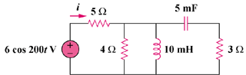

Figure 9.51
For Prob. 9.44.

